<config>  
<output path=’C:\Users\ndavis\git\OnfInfoModelOutput\ModelDescriptions\TR-512.A.13_OnfCoreIm-Appendix-SoftwareExamples.docx' />  
</config>

<context model=’C:\Users\ndavis\git\ONFInfoModel\OnfModel\CoreModel.uml' element=’{0}’ importedBundles='gmf;papyrus' searchMetamodels='true'/>

<gendoc><drop/>

Change path substrings above from “{path for output files}\” to your local path for the output files and “{path for CoreModel}\” to your local path for the Core Model. <drop/>

DELETE: Prior to publishing this –gd.docx (including for review), change path substrings above from “C:\Users\ndavis\git\OnfInfoModelOutput\” to “{path for output files}\” and from “C:\Users\ndavis\git\ONFInfoModel\OnfModel\” to “{path for CoreModel}\” <drop/>



Core Information Model (CoreModel)

TR-512.A.15

Appendix – Controller Lifecycle and Security

Version 1.6

March 2022

ONF Document Type: Technical Recommendation

ONF Document Name: Core Information Model version 1.6

**Disclaimer**

THIS SPECIFICATION IS PROVIDED “AS IS” WITH NO WARRANTIES WHATSOEVER, INCLUDING ANY WARRANTY OF MERCHANTABILITY, NONINFRINGEMENT, FITNESS FOR ANY PARTICULAR PURPOSE, OR ANY WARRANTY OTHERWISE ARISING OUT OF ANY PROPOSAL, SPECIFICATION OR SAMPLE.

Any marks and brands contained herein are the property of their respective owners.

Open Networking Foundation

1000 El Camino Real, Suite 100, Menlo Park, CA 94025

[www.opennetworking.org](http://www.opennetworking.org)

©2022 Open Networking Foundation. All rights reserved.

Open Networking Foundation, the ONF symbol, and OpenFlow are registered trademarks of the Open Networking Foundation, in the United States and/or in other countries. All other brands, products, or service names are or may be trademarks or service marks of, and are used to identify, products or services of their respective owners.

Finalizing this document once generated… delete this text prior to publication:

* Replace “{{..}}” with square brackets (which trip up Gendoc)
* Select text in document from beginning of table of contents (first line) to end of document
  + Click menu item “Update Field” (on this large block of text)
    - if “Update Table…” dialogue appears select “Update entire table”
  + Repeat “update fields” 2 more times (on the same large block of text)
    - if “Update Table…” dialogue appears select “Update entire table”
* Remove reviewer comment

Note that the table of contents and figures need to be updated several times as the table length changes the page numbering and the cross references will need to be re-updated.

Table of Contents

Disclaimer 2

Open Networking Foundation 2

Document History 4

1 Introduction 5

1.1 References 5

1.2 Definitions 5

1.3 Conventions 5

1.4 Viewing UML diagrams 5

1.5 Understanding the figures 5

1.6 Appendix Overview 5

2 Introduction to this Appendix document 6

3 Overview and Contex 6

3.1 Business context 6

3.2 Management Control Architecture 7

3.3 Controller internal architecture 9

3.4 Controller in context 10

4 Building a Controller 11

5 Formation of a Controller 12

5.1 Forming the Service Definition and the Catalogue 12

5.2 Specific service assumptions 12

5.3 Progressing through the formation 12

6 Control Service and Various Deployments 15

6.1 Forming the Service Definition and the Catalogue 15

6.2 Multiple views 16

7 Security Considerations 20

8 Timeline Examples 21

List of Figures

Figure 3-1 Business Oveview 6

Document History

| **Version** | **Date** | **Description of Change** |
| --- | --- | --- |
| 1.6 | March 2022 | Initial Version |

# Introduction to the document suite

This document is an addendum to the TR-512_v1.4 ONF Core Information Model and forms part of the description of the ONF-CIM. For general overview material and references to the other parts refer to TR-512.1.

## References

For a full list of references see TR-512.1.

## Definitions

For a full list of definition see TR-512.1.

## Conventions

See TR-512.1 for an explanation of:

* UML conventions
* Lifecycle Stereotypes
* Diagram symbol set

## Viewing UML diagrams

Some of the UML diagrams are very dense. To view them either zoom (sometimes to 400%) or open the associated image file (and zoom appropriately) or open the corresponding UML diagram via Papyrus (for each figure with a UML diagram the UML model diagram name is provided under the figure or within the figure).

## Understanding the figures

Figures showing fragments of the model using standard UML symbols and also figures illustrating application of the model are provided throughout this document. Many of the application-oriented figures also provide UML class diagrams for the corresponding model fragments (see TR-512.1 for diagram symbol sets). All UML diagrams depict a subset of the relationships between the classes, such as inheritance (i.e. specialization), association relationships (such as aggregation and composition), and conditional features or capabilities. Some UML diagrams also show further details of the individual classes, such as their attributes and the data types used by the attributes.

## Appendix Overview

This document is part of the Appendix to TR-512. An overview of the Appendix is provided in TR-512.A.1.

# Introduction to this Appendix document

This document considers the lifecycle of a system of Controllers. A Controller is an assembly of ControlConstructs etc. The ControlConstruct is discussed in TR-512.8.

This version captures the results of discussion during OIMT meetings in Q2 2021, it is intended to provide a basis for further discussion and analysis.

Using [oimt2021.MB.003-Control-architecture-outline.pptx](https://wiki.opennetworking.org/download/attachments/266141701/oimt2021.MB.003-Control-architecture-outline.pptx?api=v2) and [oimt2021.ND.002_ControlModelAndSecurity.pptx](https://wiki.opennetworking.org/download/attachments/266141701/oimt2021.ND.002_ControlModelAndSecurity.pptx?api=v2).

# Overview and Context

## Business context



Figure 3-1 Business Oveview





## Management Control Architecture

Note the MCC from 1118 (referenced in .8?)

Refactor the slide slightly…







## Controller internal architecture

Note that a controller is a recursion of what is show and that a controller will also have loop closure.

May be worth showing an overall closed loop with view and then

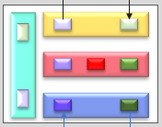



## Controller in context – deployment assumptions

### Client

* An entity (organization) that has contracted to use:
  + A set of transport network resources that are presented as a virtual network
    - *The client may use these resources to support a “slice”*
  + Management capabilities for the virtual network
  + The client has one or more agents
    - An agent is an application that acts for the client to control/manage the client’s resources. The client may assign agents different (restricted) access to the resources based on the function that they perform.

### Interfaces between the client and the provider

* Only exists in the context of a “closed” environment based on a trusted commercial relationship
  + The Ports on the controller are in a secure environment e.g., in a VPN
  + Communications are secured by the protocol used on the link
* Only machine-to-machine interfaces are supported
  + *Client agents are “applications”* (e.g., network configuration; inventory; network planning; etc.) that act for the client
    - *If required a man-machine interface (GUI) may be supported by a client agent application. The (human) users are not distinguished on the interface to the client context*
* Each client agent group (e.g., network configuration; inventory; network planning; etc.) has a dedicated view
* It is expected that
  + A client will have less than 10 user groups
  + Each user group will have ~2 users

See section 7 “*Security Considerations*” for further details

# Building a Controller

## Platform creation (network administration)

* Assign compute resources
  + Using e.g., Discrete physical compute platform; VM on a server; VM “in the cloud”; …..
  + Should be able to migrate a running controller between platforms
* Install controller software
* Configure controller admin port

## Assign network resources (network administration)

* Assign network resources
  + Create server contexts
* Configure links between adjacent controllers
  + Run DA, create LRMs

## Configure server contexts (controller admin)

* Configure server contexts
  + View translation
  + Create user groups and user credentials (to access the supporting client context views)
* Configure links between server contexts
  + Run DA; create LRMs



# Formation of a Controller

## Forming the Service Definition and the Catalogue

Explain the control service referring back to section 3 slab and the development of services etc.

May want to reverse the following sections so that the simple case is first (numbers on slides are as below, i.e., number order in the pack is decrementing).

## Specific service assumptions

## Progressing through the formation

(see section 6 for the example)







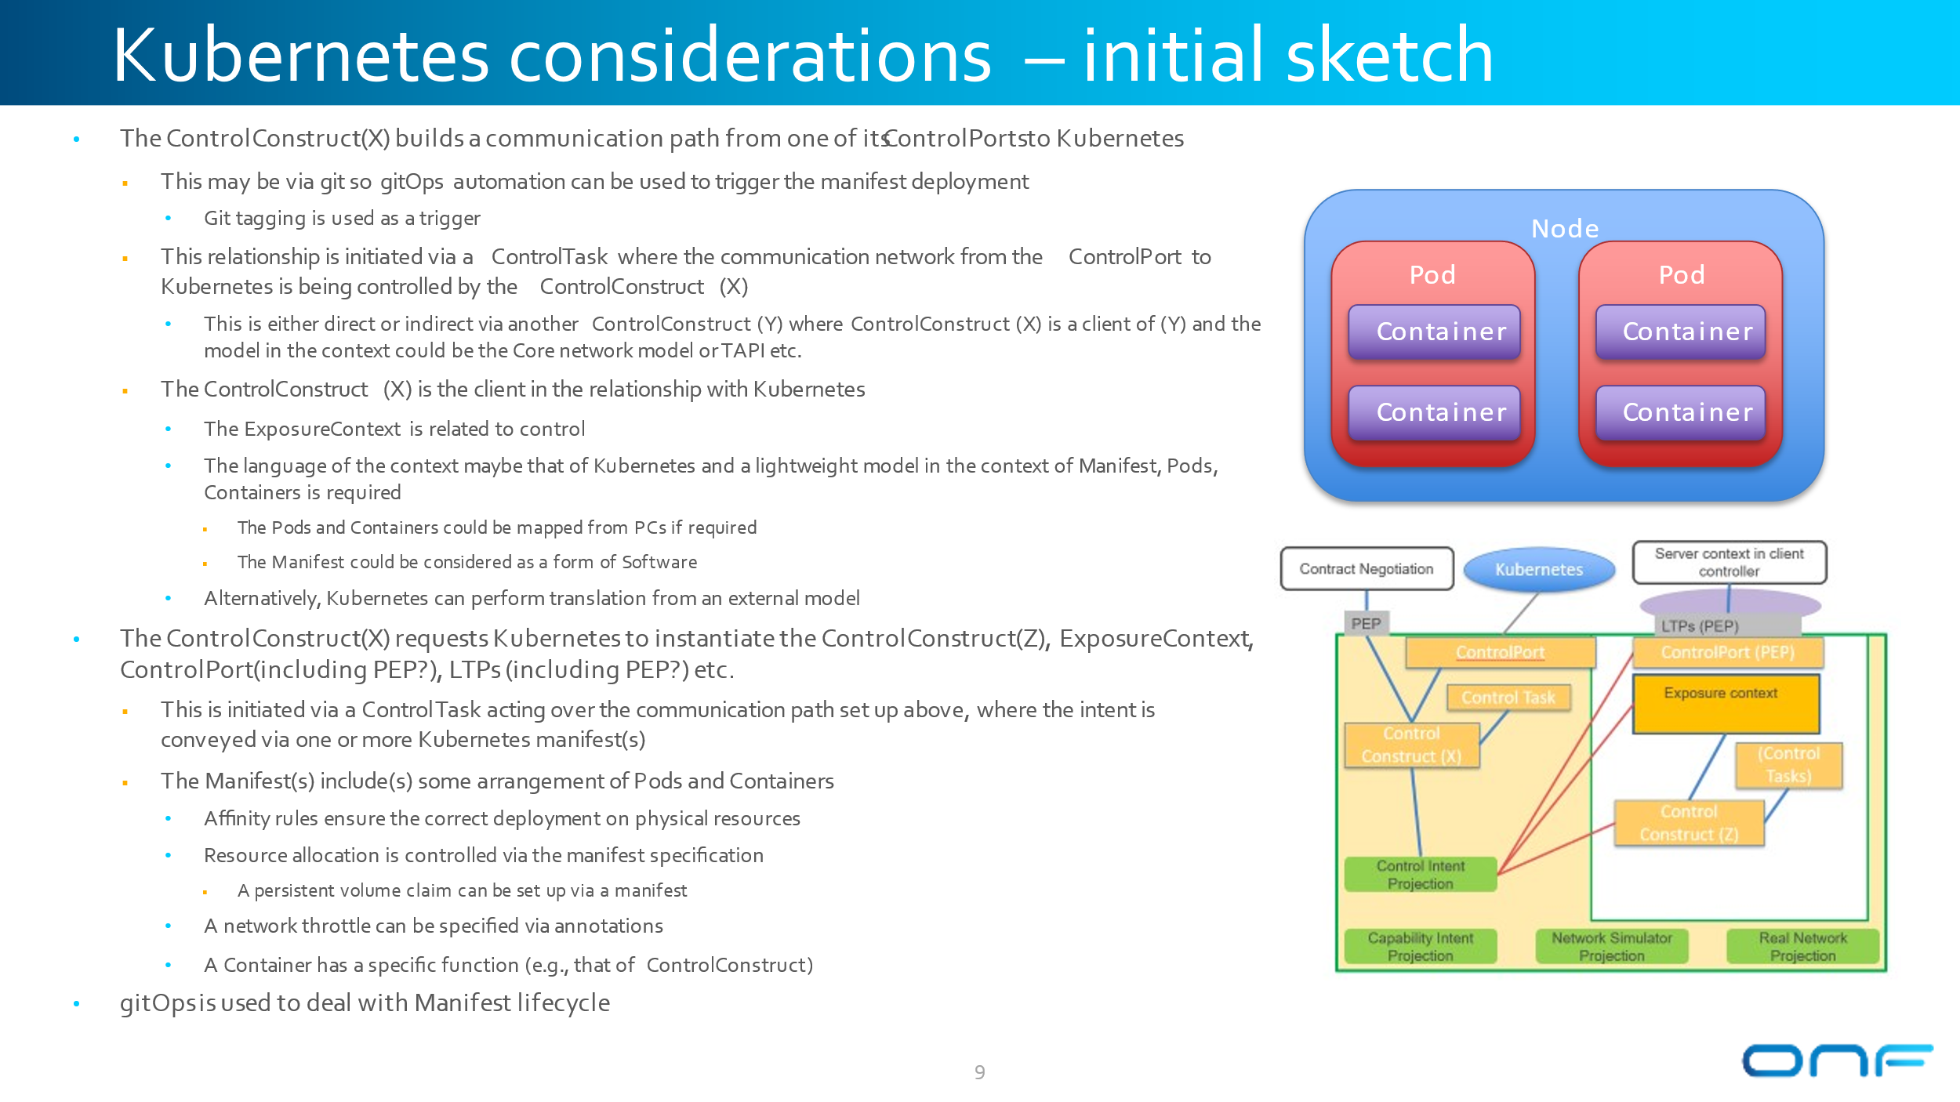

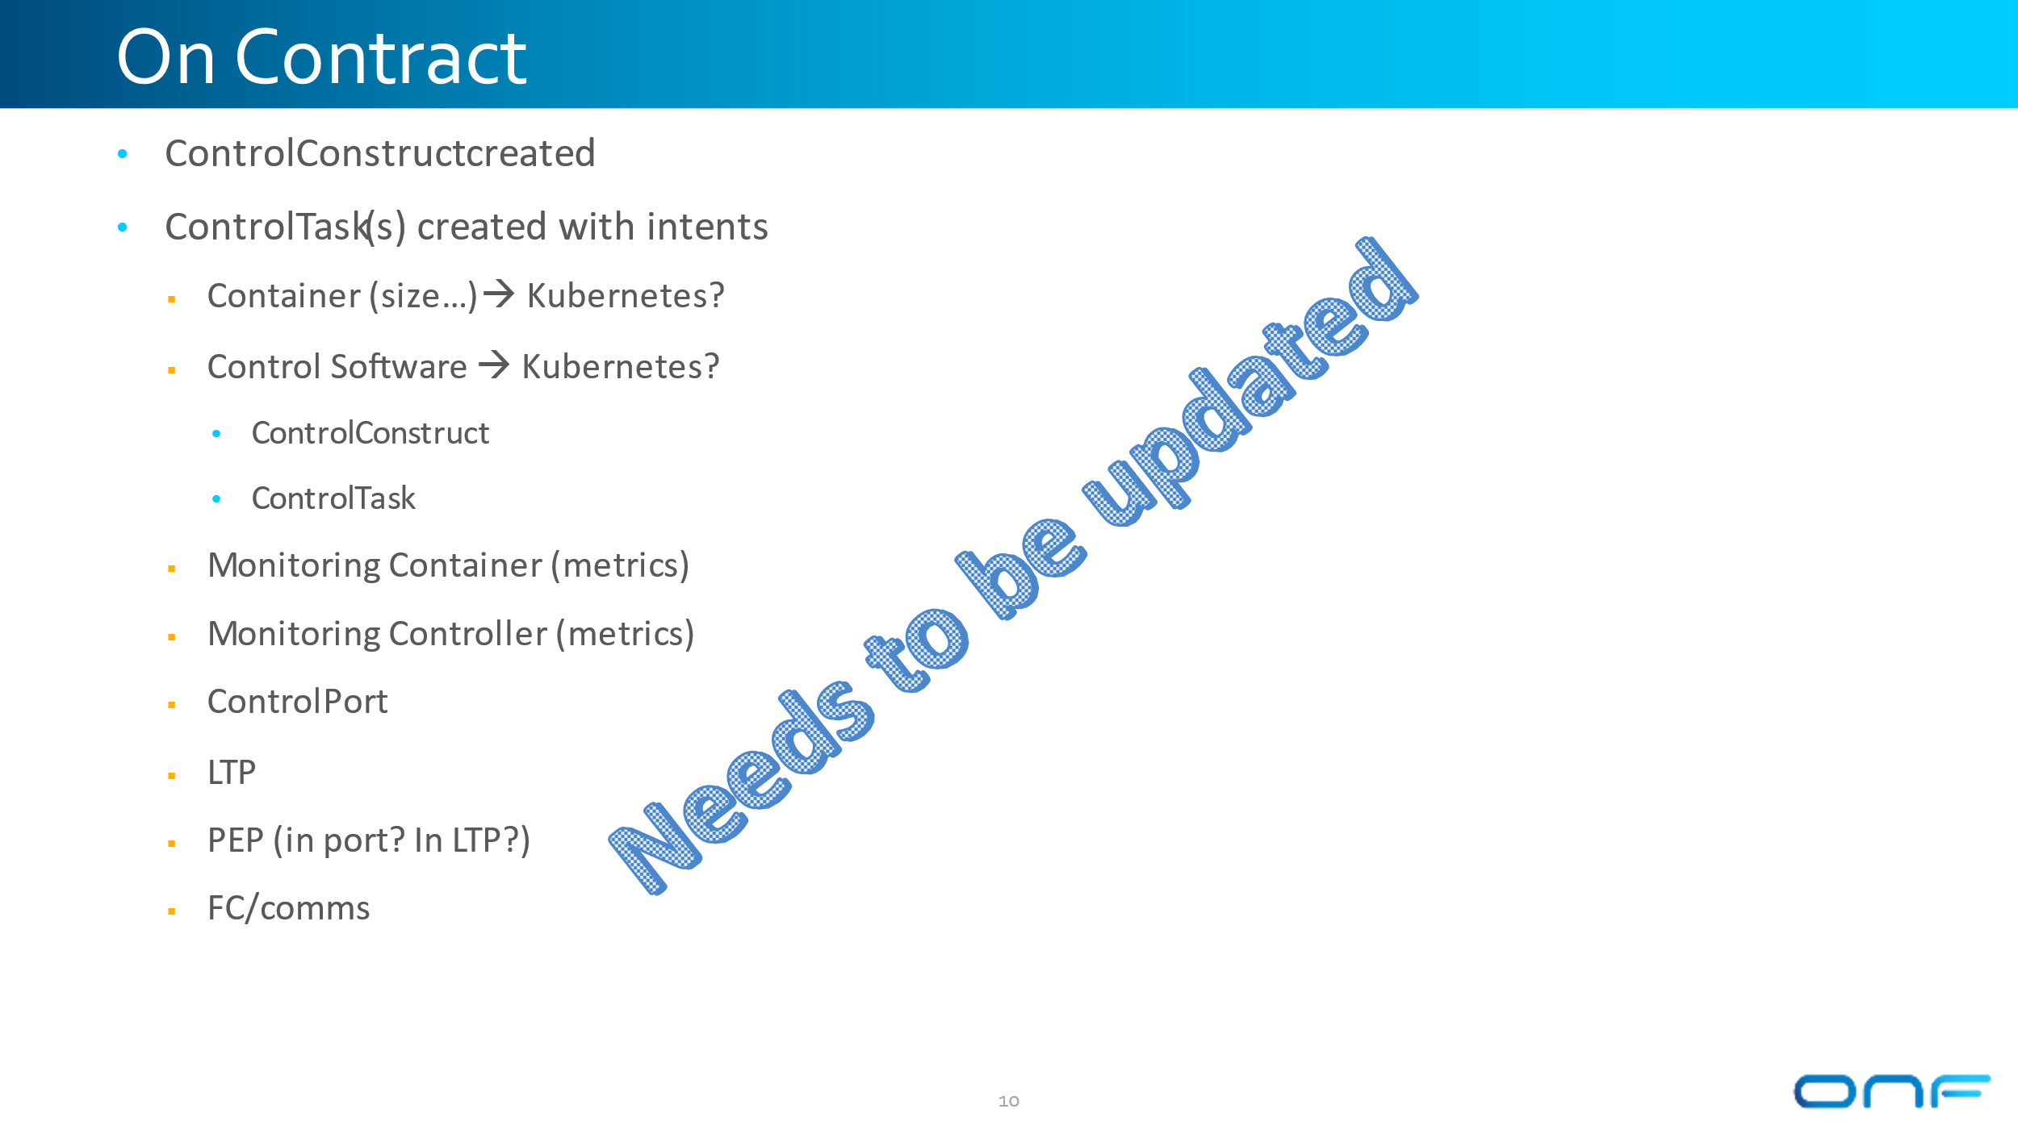

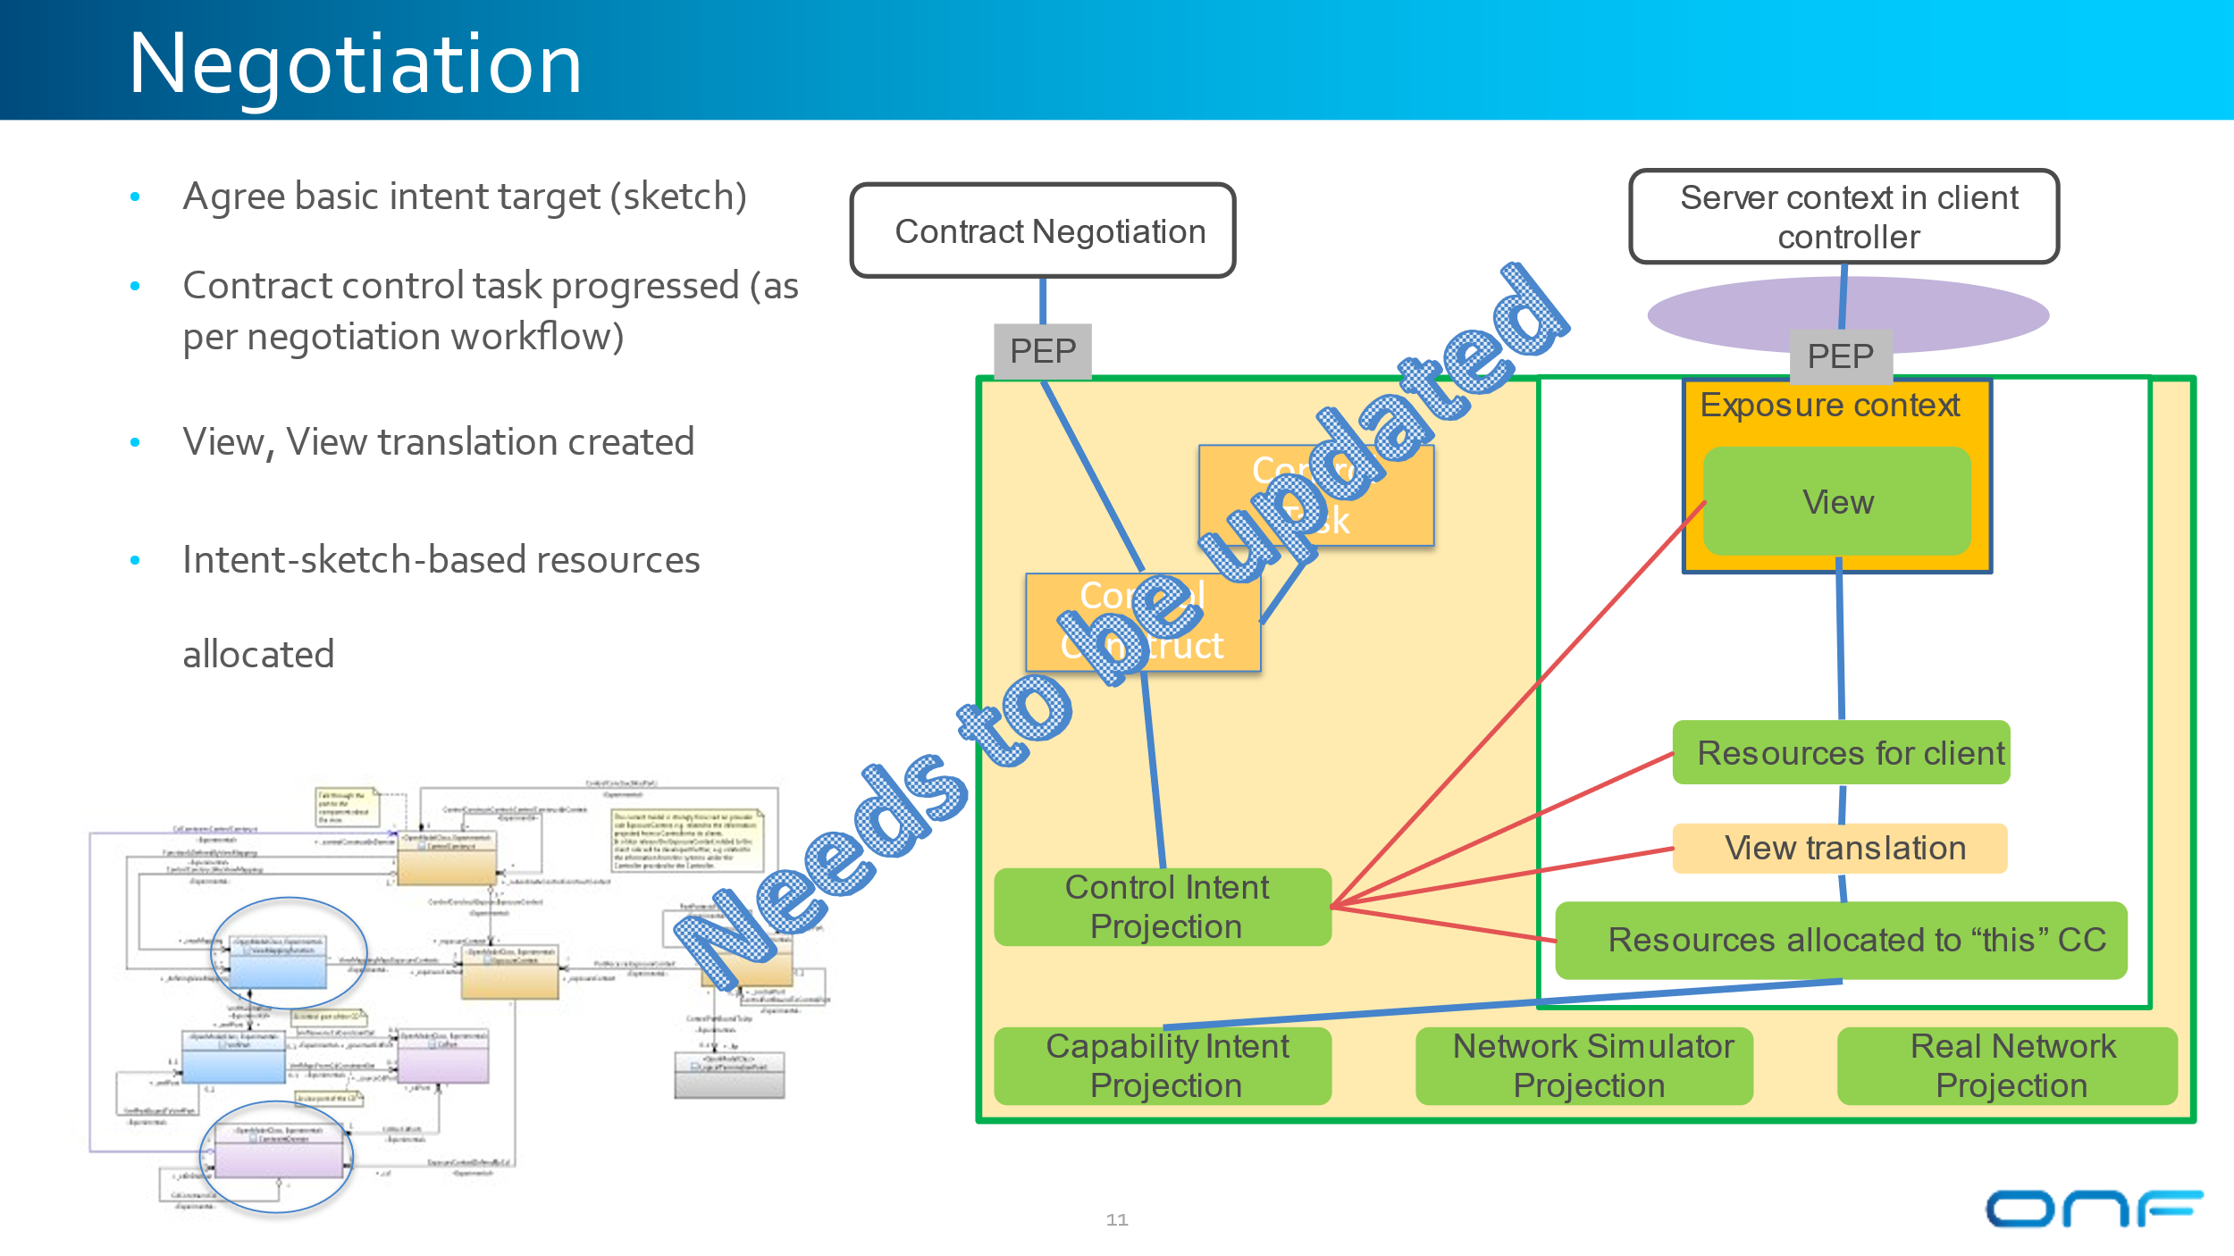

# Control Service and Various Deployments

## Forming the Service Definition and the Catalogue

Explain the control service referring back to section 3 slab and the development of services etc.

A SDN controller may be deployed in a number of different network contexts that provided different management control capabilities. Some example deployment scenarios are described below starting with the least complex may be used to check that the model is “fit for purpose”.

**1) Controller in a NE with a single client in a trusted domain**

* + One client context with one EC
  + Only local resources; single server context – no link management

**2) Controller that consolidates multiple NE’s with a single client in a trusted domain**

* + One client context with more than one EC
  + Multiple server contexts – management of links between server contexts (DA/LRM)

**3) Controller with more than one client in a trusted domain**

* + More than one client context with more than one EC
  + Multiple server contexts – management of links between server contexts (DA/LRM)
  + Controller admin defines the EC in the CC

**4) Controller with more than one client in a non-trusted domain**

* + More than one client context with more than one EC
  + Controller admin defines maximum “rate” of operations that the client can perform
  + Controller admin defines the EC on each CC

**5) Controller with more than one client in a non-trusted domain**

* + More than one client context
  + Controller admin defines maximum “rate” of operations that the client can perform
  + Controller admin defines the maximum number of ECs that can be supported
  + Client admin defines the ECs and (client) translation function

## Multiple views

Sketches of the client context for each of the scenarios are provided below. The process for building the client context is described for scenario 5.

**1) Controller in a NE with a single client in a trusted domain**



**2) Controller that consolidates multiple NE’s with a single client in a trusted domain**



**3) Controller with more than one client in a trusted domain**



**4) Controller with more than one client in a non-trusted domain**



**5) Controller with more than one client in a non-trusted domain**



### Building a client context

* **Step 1a: Controller admin user**
  + Creates client context CD; assigns resources; configures view translation 1 and view translation 2
  + Creates the client admin constraint domain and exposure context
    - Assigns platform compute resources to the client context and client admin EC
      * Client admin exposure context should “run” in container (e.g., a VM; discrete compute platform; …) to ensure that the client cannot exceed the allocated compute resources
    - Installs required software
* **Step 1b: Controller admin sets constraints**
  + Maximum number of additional exposure contexts that can be created (may be none)
  + Complexity of the view translation e.g.,
    - abstraction and subsets - allowed:
    - view transformation not supported
  + Maximum number of users
  + Maximum rate of requests/operations
    - A single request from a client may result in multiple requests to the servers.   
      For example, a request for a connection across an abstract sub-network will:
      * Require path computation (using the cc compute resources):
      * Multiple connection requests to the server contexts:
      * The rate of requests in each server context will be constrained by the corresponding client context (that provides the resources)



* **Step 2: Within the constraints set by the controller admin the client admin user**
  + Creates additional exposure contexts
  + Defines view translation 3 for each exposure context
  + Creates user credentials (to access the exposure contexts)
  + Request additional compute resources for the CC EC



# Security Considerations

* **Deployment assumptions**
  + A client context only exists in the context of a “closed” environment based on a trusted commercial relationship
  + The Ports on the controller are in a secure environment
    - e.g., behind a firewall
      * In the case of a controller is embedded in a NE (shown on slide 21) if the NE is an IP device the control traffic and user traffic may share the same port. This creates a potential point of vulnerability.   
        In a “traditional” transport NE the control port and traffic ports are fully isolated
    - The client ports should be isolated from the controller admin port e.g., in separate VPNs
  + Communications between the server context port and the client context port are secured by the protocol used on the link  
    e.g., the protocol:
    - includes non-repudiation
    - protects against man-in-the-middle attacks
* **A server context does not accept (management) connection requests**
  + The server context only initiates the set-up of (management) connections/sessions or streams
    - The controller admin provides the credentials and address of the server (client context)
  + Protocol includes “keep alive”
    - If a connection drops the server context reinitiates the connection
* **Access control for users on the EC port**
  + Policy Enforcement Point (PEP) on each EC port
    - Validates user credentials
    - Policy Decision Point (PDP) may be local or remote
  + Access of a user is controlled (constrained) by the view (EC) available to a user
    - This provides a similar function to Role-Based Attribute Control (RBAC)

**Controlled access session references**

* **An Exposure context (and access sessions) are established in the context of a trusted commercial relationship**
* **Exposure Context maps to Controlled Access Session (may be longlived)**
  + [**https://www.researchgate.net/publication/29864510_Patterns_for_session-based_access_control [researchgate.net]**](https://urldefense.com/v3/__https:/www.researchgate.net/publication/29864510_Patterns_for_session-based_access_control__;!!OSsGDw!YUNJ0X8zA3-lQ4em6Si29ISTgbvd86_CxS72s6RqOYWDSnYRKVzMfNhO-sU3$)
  + **“Patterns for session-based access control”**
  + **“2.8 Consequences**
  + **This pattern has the following advantages:** 
    - We can give to each context only the needed rights according to its function and we can invoke in a session only those contexts that are needed for a given task.
    - We can exclude combinations of contexts that might result in possible access violations or conflicts of interest.
    - Once a subject starts a session it doesn’t have to be reauthenticated. Its status is kept by the session.
  + **A possible disadvantage: If we need to apply fine-grained access it might be inefficient to open many sessions to perform complex activities.”**
* ***For our (telecoms) application with a limited number of user groups I don’t think that we need worry about the possible disadvantage.***
  + **Papers related to RBAC using Proxy Objects**
  + [**https://link.springer.com/chapter/10.1007/978-3-642-10772-6_23 [link.springer.com]**](https://urldefense.com/v3/__https:/link.springer.com/chapter/10.1007/978-3-642-10772-6_23__;!!OSsGDw!YUNJ0X8zA3-lQ4em6Si29ISTgbvd86_CxS72s6RqOYWDSnYRKVzMfALcC_Ip$)
    - We automatically build proxy objects, and give them to untrusted clients instead of the originals. Proxy objects expose a subset of methods to prevent potentially dangerous calls from clients.
  + [**https://www.researchgate.net/publication/221366972_Role-Based_Access_Control_RBAC_in_Java_via_proxy_objects_using_annotations [researchgate.net]**](https://urldefense.com/v3/__https:/www.researchgate.net/publication/221366972_Role-Based_Access_Control_RBAC_in_Java_via_proxy_objects_using_annotations__;!!OSsGDw!YUNJ0X8zA3-lQ4em6Si29ISTgbvd86_CxS72s6RqOYWDSnYRKVzMfLzVRIz8$)
    - We propose a new approach for applying Role-Based Access Control (RBAC) to methods in objects in the Java programming language. In our approach, a policy implementer (usually a developer) annotates methods, interfaces, and classes with roles. Our system automatically creates proxy objects which only contain methods to which a client is authorized access based on the role specifications.

# Timeline Examples



1. **Market research and service catalog creation**
   * Initially based on a tentative plan – few (if any) resources deployed
   * Open environment – should run in an isolated “container” to limit damage from DoS attacks
2. **Negotiation with (potential) clients**
   * Based on firm plan: Service offerings defined: Some resources may have been deployed
   * Open environment – should run in an isolated “container” to limit damage from DoS attacks
3. **Select client and negotiate contract**
   * Establish a trusted commercial relationship
   * Create a secure (closed) environment
   * Controller and client context created
     + May be created on in a “test” environment
     + Client exposure context showing the resources available to the client
       - Mix of planned and deployed resources all with an assignment state of PLANNED in the client EC
     + Server context with local planned resources together with server contexts holding deployed resources
4. **Activation of client network**
   * Resources deployed
     + Migrate the planned resources in the local server context to “real” server contexts
       - Adjust view translation to maintain a consistent view for client
     + Possibly migrate the controller to a different platform
     + Migrate the “planning” EC to an operational EC – updated assignment state of resources



**1) Create “planning” EC for the redesigned network**

* + Controller administrator adds “planned” resources to the client context
    - Additional resources are shown with an assignment state of PLANNED
      * These may be from a “planned” server context or deployed resources
  + The “planning” view includes read only proxy for all the resources in the current network
    - i.e., the current network cannot be modified in the “planning” EC
    - The planned resources are not visible in the “active” view
  + The client tags resources that are not required in the redesigned network with an assignment state of PENDING_WITHDRAWAL

**2) Activation of new client network**

* + Plan is finalized and committed
    - Transition to the “new” network will be implemented at some defined time in the future
    - Migration from the current to new network is planned
      * This may be a multi-step process to minimize disruption during network migration
      * May require the temporary assignment of resources to minimize disruption during migration
  + Resources deployed
    - Migrate the planned resources in the local server context to “real” server contexts
      * Adjust view translation to maintain a consistent view for client
  + Migrate the resources in the “planning” EC to the “current” EC
    - Update resource assignment state
    - May involve several intermediate steps (as defined in the migration plan)

**End of Document**

</gendoc><drop/>

To take latest template: <drop/>

* delete text from “Template version…” to end of file <drop/>
* insert a line in “Normal” style<drop/>
* insert text (Insert 🡪 Object 🡪 Text from File… (alt njf)) from: <drop/>
  + TR-512.GT_OnfCoreIm-CommonGendocTemplate-Fragments.docx <drop/>

Template version 0.0.11 1 June 2018 <drop/>

# Fragment: Insert class <drop/>

<fragment name=’insertClass’ importedBundles=’commons;gmf;papyrus’><drop/>  
<arg name=’cl’ type=’uml::Class’/><drop/>  
<arg name=’className’ type=’String’/><drop/>  
<arg name=’packageName’ type=’String’/><drop/>  
[if (not cl.qualifiedName.contains(packageName))]<drop/>  
[else] <drop/>  
[if(cl.name.contains(className))]<drop/>

Qualified Name: [cl.qualifiedName/]

[if cl.ownedComment->notEmpty()]<drop/>

[for (co:Comment | cl.ownedComment)] <drop/>

<dropEmpty>[cleanAndFormat(co._body.clean())/]</dropEmpty>

[/for]<drop/>

[else]To be provided

[/if]<drop/>

[if (cl.isAbstract)]<drop/>

This class is abstract.

[/if]<drop/>

[if (cl.oclAsType(uml::Class).general ->notEmpty())]<drop/>

Inherits properties from:

[for (gen:Class | cl.oclAsType(uml::Class).general)]<drop/>

* [gen.name/]

[/for]<drop/>

[/if]<drop/>

[for (st:Stereotype | cl.getAppliedStereotypes())]<drop/>  
[if(not st.name.contains(‘OpenModelClass’))]<drop/>

This class is [st.name/].

[else] <drop/>  
[/if]<drop/>  
[/for]<drop/>  
[else] <drop/>  
[/if]  
[/if]  
</fragment><drop/>

# Fragment: Insert standard diagram <drop/>

<fragment name=’insertStandardDiagram’ importedBundles=’commons;gmf;papyrus’><drop/>  
<arg name=’p’ type=’uml::Package’/><drop/>  
<arg name=’diagramName’ type=’String’/><drop/>  
<arg name=’diagramTitle’ type=’String’/><drop/>

[for (d:Diagram|p.getPapyrusDiagrams())]<drop/>

[if d.name.contains(diagramName)]

<drop/>

<image object='[d.getDiagram()/]' maxW='true' keepH='false' keepW = ‘false’></image>

CoreModel diagram: [d.name/]

Figure 6-2 [diagramTitle/]

[else]<drop/>

[/if]<drop/>

[/for]<drop/>  
</fragment><drop/>

# Fragment: Insert small diagram <drop/>

<fragment name=’insertSmallDiagram’ importedBundles=’commons;gmf;papyrus’><drop/>  
<arg name=’p’ type=’uml::Package’/><drop/>  
<arg name=’diagramName’ type=’String’/><drop/>  
<arg name=’diagramTitle’ type=’String’/><drop/>

[for (d:Diagram|p.getPapyrusDiagrams())]<drop/>

[if d.name.contains(diagramName)]

<drop/>

<image object='[d.getDiagram()/]' maxW='true' keepH='false' keepW = ‘false’></image>

CoreModel diagram: [d.name/]

Figure 6-2 [diagramTitle/]

[else]<drop/>

[/if]<drop/>

[/for]<drop/>  
</fragment><drop/>

# Fragment: Insert attribute row brief not Obsolete<drop/>

<fragment name=’insertAttributeRowBriefNotObsolete’ importedBundles=’commons;gmf;papyrus’><drop/>

Does not work unless we have Mature stereotype… <drop/>  
<arg name=’p’ type=’uml::Property’/><drop/>

[for (st:Stereotype | p.getAppliedStereotypes())]<drop/>

[if(not st.name.contains(‘OpenModelAttribute’))]

[if(not st.name.contains(‘Obsolete’))]

| [p.name/] | [for (st:Stereotype | p.getAppliedStereotypes())]<drop/>  [if(not st.name.contains(‘OpenModelAttribute’))] [st.name/]  [/if]<drop/>  [/for]<drop/>  Do NOT remove the previous line as word throws an error if the cell is empty <drop/> | [if p.ownedComment->notEmpty()]<drop/>  [for (c:Comment | p.ownedComment)] <drop/>  [cleanAndFormat(c._body.clean())/]  [/for]  [else] [if (p.name.contains (‘_’))]See referenced class  [else]To be provided  [/if]<drop/>  [/if]<drop/>  Do NOT remove the previous line as word throws an error if the cell is empty <drop/> |
| --- | --- | --- |

[/if]<drop/>

[/if]<drop/>

[/for]<drop/>  
</fragment><drop/>

# Fragment: Insert attribute row brief <drop/>

<fragment name=’insertAttributeRowBrief’ importedBundles=’commons;gmf;papyrus’><drop/>  
<arg name=’p’ type=’uml::Property’/><drop/>

| [p.name/] | [for (st:Stereotype | p.getAppliedStereotypes())]<drop/>  [if(not st.name.contains(‘OpenModelAttribute’))] [st.name/]  [/if]<drop/>  [/for]<drop/>  Do NOT remove the previous line as word throws an error if the cell is empty <drop/> | [if p.ownedComment->notEmpty()]<drop/>  [for (c:Comment | p.ownedComment)] <drop/>  [cleanAndFormat(c._body.clean())/]  [/for]  [else] [if (p.name.contains (‘_’))]See referenced class  [else]To be provided  [/if]<drop/>  [/if]<drop/>  Do NOT remove the previous line as word throws an error if the cell is empty <drop/> |
| --- | --- | --- |

</fragment><drop/>

# Fragment: Start attribute table brief <drop/>

<fragment name=’insertAttributeTableHeader’ importedBundles=’commons;gmf;papyrus’><drop/>  
<arg name=’cl’ type=’uml::Class’/><drop/>

|  |  |  |
| --- | --- | --- |
| **Attribute Name** | **Lifecycle Stereotype (empty = Mature)** | **Description** |

</fragment><drop/>

# Fragment: Insert Attribute table brief <drop/>

<fragment name=’insertAttributeTableBrief’ importedBundles=’commons;gmf;papyrus’ importedFragments='insertAttributeTableHeader;insertAttributeRowBrief’><drop/>  
<arg name=’cl’ type=’uml::Class’/><drop/>  
[if cl.ownedAttribute->notEmpty()]<drop/>

Table 1: Attributes for [cl.name/]

<table><drop/>

[cl.insertAttributeTableHeader ()/]

[for (p:Property|cl.ownedAttribute)]<drop/>

[if (not p.name.contains(‘_’))]<drop/>

[p.insertAttributeRowBrief ()/]

[/if]<drop/>

[/for]<drop/>

[for (p:Property|cl.ownedAttribute)]<drop/>

[if (p.name.contains(‘_’))]<drop/>

[p.insertAttributeRowBrief ()/]

[/if]<drop/>

[/for]<drop/>

</table><drop/>

[/if]<drop/>

</fragment><drop/>

# Fragment: Insert Ten Specified Attribute table brief <drop/>

<fragment name=’insertTenSpecifiedAttributeTableBrief’ importedBundles=’commons;gmf;papyrus’ importedFragments='insertAttributeTableHeader;insertAttributeRowBrief’><drop/>  
<arg name=’cl’ type=’uml::Class’/><drop/>

<arg name=’p1’ type=‘String’/><drop/>

<arg name=’p2’ type=‘String’/><drop/>  
<arg name=’p3’ type=‘String’/><drop/>  
<arg name=’p4’ type=‘String’/><drop/>  
<arg name=’p5’ type=‘String’/><drop/>  
<arg name=’p6’ type=‘String’/><drop/>  
<arg name=’p7’ type=‘String’/><drop/>  
<arg name=’p8’ type=‘String’/><drop/>  
<arg name=’p9’ type=‘String’/><drop/>  
<arg name=’p10’ type=‘String’/><drop/>  
[if cl.ownedAttribute->notEmpty()]<drop/>

Table 1: Attributes for [cl.name/]

<table><drop/>

[cl.insertAttributeTableHeader ()/]

[for (p:Property|cl.ownedAttribute)]<drop/>

[if (p.name.contains(p1) or p.name.contains(p2) or p.name.contains(p3) or p.name.contains(p4) or p.name.contains(p5) or p.name.contains(p6) or p.name.contains(p7) or p.name.contains(p8) or p.name.contains(p9) or p.name.contains(p10))]<drop/>

[if (not p.name.contains(‘_’))]<drop/>

[p.insertAttributeRowBrief ()/]

[/if]<drop/>

[/if]<drop/>

[if (p.name.contains(p1) or p.name.contains(p2) or p.name.contains(p3) or p.name.contains(p4) or p.name.contains(p5) or p.name.contains(p6) or p.name.contains(p7) or p.name.contains(p8) or p.name.contains(p9) or p.name.contains(p10))]<drop/>

[if (p.name.contains(‘_’))]<drop/>

[p.insertAttributeRowBrief ()/]

[/if]<drop/>

[/if]<drop/>

[/for]<drop/>

</table><drop/>

[/if]<drop/>

</fragment><drop/>

# Fragment: Insert DataType <drop/>

<fragment name=’insertDataType’ importedBundles=’commons;gmf;papyrus’><drop/>  
<arg name=’dt’ type=’uml::DataType’/><drop/>  
<arg name=’dataTypeName’ type=’String’/><drop/>  
<arg name=’packageName’ type=’String’/><drop/>  
[if (dt.qualifiedName.contains(packageName))]<drop/>  
[if(dt.name.contains(dataTypeName))]<drop/>

Qualified Name: [dt.qualifiedName/]

[for (co:Comment | dt.ownedComment)]<drop/>

<dropEmpty>[cleanAndFormat(co._body.clean())/]</dropEmpty>

[/for]<drop/>  
[if (dt.oclAsType(uml::DataType).general ->notEmpty())]<drop/>

Inherits properties from:

[for (tp:DataType | dt.oclAsType(uml::DataType).general)]<drop/>

* [tp.name/]

[/for]<drop/>

[for (gen:Class | dt.oclAsType(uml::DataType).general)]<drop/>

* [gen.name/]

[/for]<drop/>

[/if]<drop/>

[for (st:Stereotype | dt.getAppliedStereotypes())]<drop/>  
This class is [st.name/].

[/for]<drop/>  
[else] <drop/>  
[/if]  
[/if]  
</fragment><drop/>

# Fragment: Start Data Type attribute table brief <drop/>

<fragment name=’insertDataTypeAttributeTableHeader’ importedBundles=’commons;gmf;papyrus’><drop/>  
<arg name=’dt’ type=’uml::DataType’/><drop/>

|  |  |  |
| --- | --- | --- |
| **Attribute Name** | **Lifecycle Stereotype (empty = Mature)** | **Description** |

</fragment><drop/>

# Fragment: Insert Data Type Attribute table brief <drop/>

<fragment name=’insertDataTypeAttributeTableBrief’ importedBundles=’commons;gmf;papyrus’ importedFragments='insertDataTypeAttributeTableHeader;insertAttributeRowBrief’><drop/>  
<arg name=’dt’ type=’uml::DataType’/><drop/>  
[if dt.ownedAttribute->notEmpty()]<drop/>

Table 1: Attributes for [dt.name/]

<table><drop/>

[dt.insertDataTypeAttributeTableHeader ()/]

[for (p:Property|dt.ownedAttribute)]<drop/>

[p.insertAttributeRowBrief ()/]

[/for]<drop/>

</table><drop/>

[/if]<drop/>

</fragment><drop/>

# Fragment: Insert enums <drop/>

<fragment name=’insertEnums’ importedBundles=’commons;gmf;papyrus’><drop/>  
<arg name=’dt’ type=’uml::DataType’/><drop/>

#### [dt.name/]

Qualified Name: [dt.qualifiedName/]

[for (co:Comment | dt.ownedComment)]<drop/>

<dropEmpty>[cleanAndFormat(co._body.clean())/]</dropEmpty>

[/for]<drop/>

Applied stereotypes:

[if dt.getAppliedStereotypes()->notEmpty()] <drop/>

[for (st:Stereotype | dt.getAppliedStereotypes())]<drop/>

* [st.name/]

[/for]<drop/>

[else] No stereotypes applied

[/if]<drop/>

[if (dt.oclAsType(uml::DataType).general ->notEmpty())]<drop/>

Inherits literals from:

[for (tp:DataType | dt.oclAsType(uml::DataType).general)]<drop/>

* [tp.name/]

[/for]

[/if]<drop/>

[if (dt.oclAsType(Enumeration).ownedLiteral->notEmpty())]<drop/>

Contains Enumeration Literals:

[for (e:EnumerationLiteral|dt.oclAsType(Enumeration).ownedLiteral)]<drop/>

* [e.name/]:
  + [for (co:Comment | e.ownedComment)]<drop/>
  + <dropEmpty>[cleanAndFormat(co._body.clean())/]
  + </dropEmpty>[/for]<drop/>
  + [if dt.getAppliedStereotypes()->notEmpty()] <drop/>
  + Applied stereotypes:
    - [for (st:Stereotype | e.getAppliedStereotypes())]<drop/>
    - [st.name/]
    - [/for]<drop/>
  + [/if]<drop/>

[/for]<drop/>

[/if]<drop/>

</fragment><drop/>